GOOD COP BAD COP 2025 ONLINE CONFERENCE
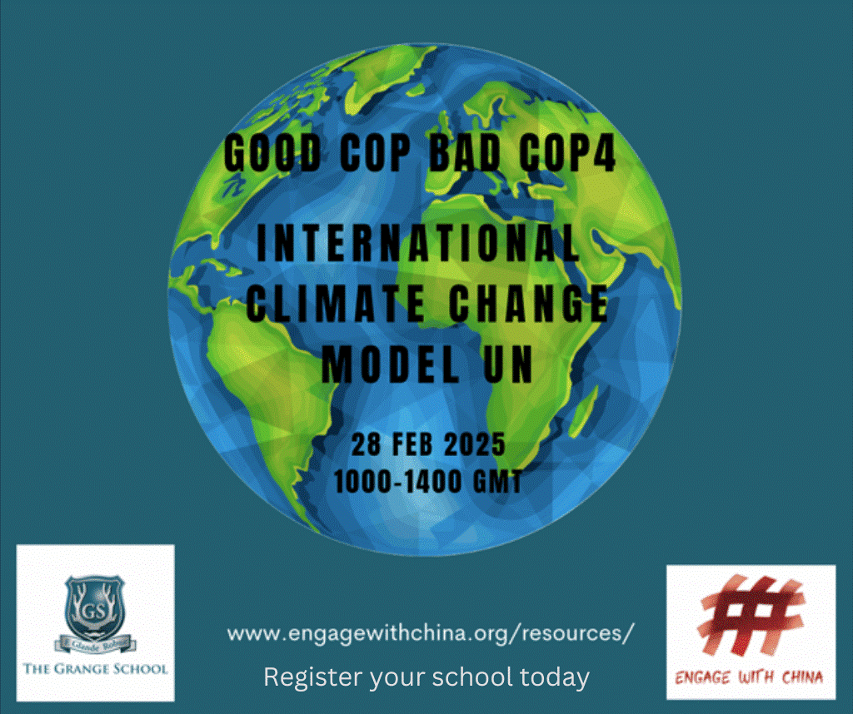
FRIDAY 28 FEBRUARY 2025 – 1000-1400 GMT / 1800 – 2200 CHINA TIME

SCHOOL REGISTRATION FORM

INFORMATION ABOUT YOUR SCHOOL
SCHOOL NAME
TYPE OF SCHOOL | Private/independent State
 | Day school Boarding school
PUPIL INTAKE | Boys Girls Both
PUPIL AGE RANGE
IS YOUR SCHOOL PART OF AN ACADEMY OR NETWORK OF SCHOOLS? | YES  NO
IF YES, WHAT IS THE NAME OF THE ACADEMY TRUST OR NETWORK?
DO YOU HAVE PARTNERSHIP LINKS WITH OTHER SCHOOLS IN YOUR AREA, eg feeder schools / resources / projects
INFORMATION ABOUT YOU
TEACHER CONTACT NAME
JOB ROLE/TITLE
CONTACT EMAIL
CONTACT PHONE NUMBER
PREVIOUS MUN OR DEBATING EXPERIENCE
HAS YOUR SCHOOL HAD PREVIOUS INVOLVEMENT WITH MODEL UNITED NATIONS CONFERENCES? | YES  NO
DOES YOUR SCHOOL HAVE A DEBATING SOCIETY? | YES  NO
IF NO TO EITHER OF THE ABOVE QUESTIONS, WOULD YOU LIKE TO TAKE ADVANTAGE OF OUR FREE PRE-CONFERENCE WORKSHOPS | YES  NO  MAYBE
HOW MANY PUPILS DO YOU HOPE WILL ATTEND THE MUN FROM YOUR SCHOOL? [MINIMUM 10]
RESPONSIBLE ROLES
WOULD YOUR SCHOOL LIKE TO APPLY TO CHAIR A BREAKOUT ROOM? | YES  NO  MAYBE / DON’T KNOW YET
WOULD YOUR SCHOOL LIKE TO APPLY TO SUBMIT A RESOLUTION FOR THE CONFERENCE? | YES  NO  MAYBE / DON’T KNOW YET
ECO PROJECT  AS PART OF THE ETHOS OF THE ENGAGE WITH CHINA GOOD COP BAD COP MUN WE ARE ENCOURAGING PARTICIPATING STUDENTS AND SCHOOLS TO BECOME ACTIVELY ENGAGED WITH ENVIRONMENTAL SUSTAINABILITY AND TO CONSIDER DEVELOPING A PROJECT – BIG OR SMALL - WITHIN THE SCHOOL AND/OR LOCAL COMMUNITY AFTER THE MUN.  FOR A SMALL ADDITIONAL FEE OF £100* YOUR SCHOOL WOULD HAVE ACCESS TO AND BENEFIT FROM:  - UP TO SIX HOURS OF PROFESSIONAL ADVICE FROM ONE OF OUR BUSINESS MENTORS WHO WOULD BE AVAILABLE TO SUPPORT YOUR PROJECT PLANNING AND IMPLEMENTATION  - PARTICIPATION IN AN ONLINE EVENT IN THE SUMMER 2023 TO SHOWCASE PROJECTS AND LEARNINGS | YES  NO  MAYBE / DON’T KNOW YET
TEACHER SIGNATURE
PRINT NAME
DATE

Engage with China is an educational charity building China literacy in UK schools. Our curriculum enrichment ‘China Challenge Days’ have been developed for all key learning stages. Outcomes include fostering greater global awareness, building competitive edge, enhancing cultural capital and developing an understanding of living in the wider world. Our annual, international MUN conference, provides a unique platform of engagement for the next generation of young leaders to interact and debate climate change, an issue of global significance. A summary account of the conference can be found here: https://engagewithchina.org/2022/03/10/students-at-global-model-un-blown-away-by-standard-of-debate/

For more information please contact:
Theresa Booth: 07469 848897 / theresabooth@engagewithchina.org
Registered office: 52 Gloucester Terrace, London W2 3HH Charity Number: 1184881

